Kilmore Diocesan Assembly 2007
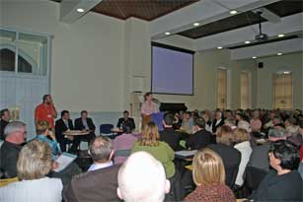
Over 250 lay-people, priests and religious gathered in the Pastoral Centre on Saturday last the 20thof October for the Kilmore Diocesan Assembly.
Representatives from all 36 parishes in the diocese took part in a day of reflection and discussion about the future. The theme of the day was ‘Vocations Now – Crisis as Grace?’ This theme emerged following consultation with Parish Pastoral Councils over the past year. The fall in the number of vocations to the priesthood and religious life and the ageing profile of the present clergy has brought a new awareness to people of the challenges and changes that lie ahead. At present there are about 75 priests working in the diocese but in 10 years time this number could be as low as 40. This realisation has given rise to a new urgency in the area of vocations promotion and also to encouraging lay people to take a more active role in their parishes.
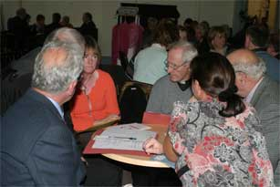
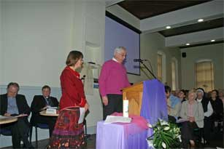
The assembly focused on how we can operate as a Church with fewer priests and how we can promote vocations to the priesthood and religious life in this post-modern culture where such long term commitment is often frowned upon.
Bishop Leo O’Reilly and Fr. Gerry Kearns welcomed the delegates to the Assembly and showed them an audiovisual presentation outlining the progress since the last diocesan assembly in the year 2000 and the results of the consultation process with parishes over the past year. Martin Kennedy, the facilitator for the day, then introduced 7 people from around the diocese who gave an input on what their vision was for the future and how we might plan effectively for the huge changes that will take place. The speakers were Fr. Ultan McGoohan, curate in Cootehill and the youngest priest in the diocese, Elizabeth Laragy a young woman from Ballyjamesduff who works in the media, Sr. Rita Duignan the Pastoral Assistant in the Annagh, Drumlane, Castletara cluster of parishes, Barry Elliot, a business man from Cavan town and his wife Mary, Fr. P.J. Sexton a native of Killinkere who is a lecturer in the Mater Dei institute in Dublin and Suzie Duffy a member of the diocesan pastoral team.
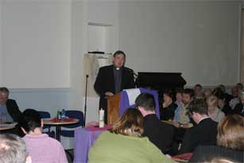
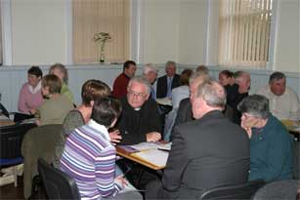
The input from the speakers was wide-ranging, thought provoking and very well received by the delegates who had an opportunity to discuss what was said in small groups. These groups also tried to pinpoint some priorities for the diocese in the years ahead.
After lunch Dr. Eamonn Conway head of Theology and Religious Studies in Mary Immaculate College in Limerick, responded to the feedback from the morning session. He encouraged those present to move from maintenance to mission and engage with people especially young people and those who have drifted from the Church. He quoted Cardinal Walter Kasper who said "Don’t try to bring people back to where they were or try to bring them to where you are but journey together to a new place". We are in danger , he said, of becoming too attached to one form of church, which may be reaching its expiry date, and not giving enough energy to evangelisation and reaching out to all.
More group discussion followed Dr Conway’s talk as delegates attempted to set some goals for action in their own parishes. After feedback from these groups was received Bishop Leo O’Reilly gave his response to what had emerged from the day and encouraged all those present to not be afraid but to face the future with confidence and to see in all the challenges and difficulties as grace that will lead to new life in the Church in Kilmore.
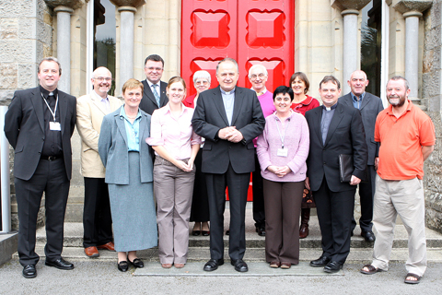

Some of the main outcomes from the day included:
• The need to make lay people more aware of the role they can play in the work of the local church and to encourage them to be more involved in its mission especially in the home, the community and the workplace.
• The need for a more positive attitude from the church towards young people. To stop being negative about their lack of involvement but to reach out and listen to them, to recognise their deep spirituality and to engage them where their interests lie.
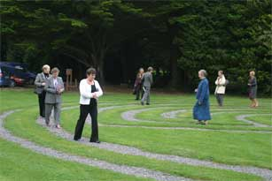
• The need for new initiatives in prayer and in the liturgical life of the church so that people are attracted to what we have to offer in this regard

The day concluded with Mass in the Cathedral at 7.30pm.

