**DROMAHAIR – KILLARGUE- NEWTOWNMANOR**

Fr Paul Casey P.P. - Telephone: 071-9164143; Email: drumahaire@kilmorediocese.ie

**Neighbouring Priests:** Fr Tom McManus, Drumkeeran – 071-9648025; Fr Patsy McDermott, Killenummery – 087-7116685; Fr John Gilhooly, Manorhamilton – 071-9855042; Fr Samuel Kure, Glencar – 071-9855433.

**Gardaí – Manorhamilton:** 071-9820620; **Samaritans – Sligo:** 071-9142011; **Accord – Sligo:** 071-9145641.

# Sunday 25th April 2021 – The Fourth Sunday of Easter (Vocations Sunday)

**Day of Prayer for Vocations – ‘The Good Shepherd’**

In Jesus’ time, being a shepherd *was not a pleasant job*. Sheep became easily lost and the *shepherd’s job* ***was to guide them*** back to safety. There were many dangers, and the sheep were totally dependent on the shepherd. Shepherds would round up their sheep in the evening and guide them into their pen. But it *had no gate*, so the ***shepherd would have to lie across*** the space in case the *sheep were attacked* in the night. *The shepherds literally* lay down their lives for their flock. *John compares the* **sacrifice of the shepherd** to the *‘hired hand’* who is not really committed to the flock. He does what he has to but flees at the first sign of trouble.

This Good Shepherd Sunday the Gospel describes Jesus as ***the ‘genuine’ Shepherd*** who wants a *personal relationship with each one of us* and who would lay down his life for us. The Gospel emphasises the *importance of relationship* as the shepherd knows his flock and cares for them. They **‘Follow Him’** and it *is not a Facebook or Twitter type* of following, rather it is a genuine relationship. Everyone matters to the Good Shepherd, regardless of their situations. We are told ‘I know my own and my own know me’. We are called today to follow Jesus in a more personal more intimate way. Even when we stray off the path and get lost, it is then especially that the Good Shepherd comes looking for us.

*‘We think we are running from God, but in fact we are running into his arms’. (Meister Eckhart)*

**The Sacrament of Baptism:** Baptisms are now allowed to take place. Please note the **maximum allowed at each baptism is 6 people** and gatherings afterwards are discouraged, due to the continued risk posed by the coronavirus. Please contact Fr Paul for more information or to arrange your child’s baptism.

**Funerals**: The numbers of people attending funerals will be increased to 25 from this Monday, 26th April

**Trócaire - give what you can it’s not too late:** We are really enormously appreciative of the support you give to Trócaire in caring for the poorest of the poor. Please use the box or any envelope to donate to Trócaire through the parish office. Thank you on behalf of our brothers and sisters who live in poverty and injustice.

***Please give what you can, it will make all the difference.***

**Public Masses**: While we do not have a clear indication just yet, it is hoped that Masses will resume in early May, depending on the level of positive covid cases in the coming weeks. Please continue to keep up the good work and to follow guidelines.

**RECENTLY DECEASED: Fr Fintan McKiernan P.E.,** retired P.P, of Derrylin & former C.C. in Glencar & Glenfarne, whose funeral took place on Saturday 24th April. **Francis Harte,** Killcoosey & Coolock, Dublin, whose funeral took place on Tuesday 20th April. ***May they Rest in Peace. Amen***

###### Prayer for Vocations

###### *God our Father, send workers into your harvest. May the Spirit we received in baptismtouch the hearts of many to offer themselves in priesthood, religious life and other forms of service.*

###### *Give the parents and families of our parish, the courage to support young people in  following the call of God in their lives, Amen.*

**ST. PATRICK’S CHURCH, DROMAHAIR:**

1. **Mass:** **No Mass on Monday’s;** Tuesday at 8.00pm; Wednesday at 9.30am; Thursday at 8.00pm; Friday at 8.00pm; Saturday (Vigil) Mass at 8.00pm; Sunday at 11.15am.

##### To access the webcam please type the following in your search engine. www.churchtv.ie *then click on County Leitrim icon, and then, click on the Dromahair icon, then click play.*

1. **Pray for:**

**Paddy O’Hara,** Sheskin, his parents **Pat & Margaret O’Hara** & his nephew **Pat Kerins.** Anniv. Mass on Saturday 24th April at 8.00pm *(streamed live).*

**Kathleen & Steve Reid,** Harrow, London**.** Mass on Sunday 25th April at 11.15am *(streamed live).*

**Kathleen McCawley.** Dowra. MemorialMass on Tuesday 27th April at 8.00pm *(streamed live).*

**Marie McDermott.** Sligo. Memorial Mass on Wednesday 28th April at 9.30am *(streamed live)*.

**Special Intention.** Mass on Thursday 29th April at 8.00pm *(streamed live)*.

**Francis & Mary McPadden,** and their **baby son, John.** Dowra**.** Mass on Fri30th April at 8.00pm

**Deceased of the Slevin Family,** Lemascally,& the **McTernan Family,** Gurteen. Anniv. Mass on Saturday 1st May at 8.00pm *(streamed live).*

**Sean & Terry McGowan,** Market St**. Patsy Devaney, his Parents, Margaret & John Devaney, and his sister, Bridget Feeney.** Mass on Sunday 2nd May at 11.15am *(streamed live).*

***May they Rest in Peace. Amen.***

**Act of Spiritual Communion**

**My Jesus, I believe that you are present in the Most Holy Sacrament.**

**I love you above all things, and I desire to receive you into my soul.**

**Since I cannot at this moment receive you sacramentally, come at least spiritually into my heart.**

**I embrace you as if you were already there and unite myself wholly to you.**

**Never permit me to be separated from you.**

**SINCERE THANK YOU:** To all who have dropped in their parish envelopes for the support of the parish. You can continue to drop Dues/Offertory Collection Envelopes into Fr Paul at the Parochial House in Dromahair (or to John McMorrow in Killargue). **Please do not leave Collection Envelopes in any of the three churches while unattended.** Thank you for your generosity & understanding.

**Annual Diocesan Vocations & Support Services** Collection is taken up this weekend 24th /25th April. This is the only collection during the year to meet diocesan commitments. We have to pay for the training of Priests, safeguarding children, marriage preparation and support, diocesan staff etc. This adds up to a considerable sum. This year each parish must pay 15% of the total Offertory Collection. Please support

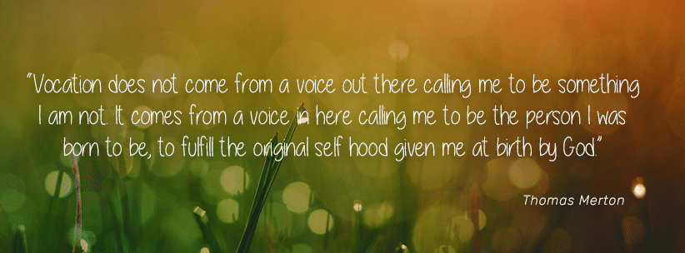

**RECEIPTS FOR 2020:**

On behalf of the Parish Finance Committee, **I wish to thank you for your generosity and kindness towards the parish in these difficult times.** Receipts for your contributions for 2020 were posted out recently.

If your contribution exceeded **€250** and you had not already returned your **CHY3 Tax form** (yellow form), there is a new form enclosed.I would encourage all **TAXPAYERS** to complete and sign this form and please return it back to the parish. This form will allow the parish to claim back tax paid on your donation during 2020. The amount of €14,460.00 was recovered from Revenue under this scheme for 2019. This is and will be an important source of income for our parish. Thank you for your help with this. **Fr Paul.**